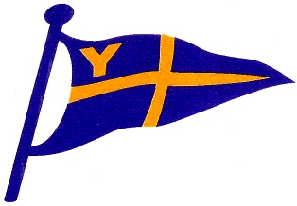
Yealm Yacht Club

YYC Safety Boat Skipper Registration

Skippers of YYC safety boats should be familiar with the club boats and with RYA recommended safety boat procedures**.
To help us provide the best safety cover, the club maintains a list of competent safety boat skippers. All safety boat skippers should be included on the list.
If you are willing to be a safety boat skipper or feel you need further training, please complete the following:-

Name (please print) .................................................................................................................

Address..........................................................................................................................................

Email address.......................................................Contact number...............................................

I am familiar with YYC Safety Boats, RYA safety boat procedures** and feel competent to act as skipper of
- Club Launch

- Orange Boat

Whether or not you currently feel competent to skipper club boats, if you would like further training arranged by the club please indicate below
- I would like basic training /familiarisation

- I would like further training in powerboat handling

- I would like RYA powerboat level 2 training

- I have power boat level 2 and would like to do RYA safety boat training

** A copy of the RYA safety boat handbook is available in the clubhouse.

Please return this completed form to a member of the sailing committee or leave behind the Bar FAO Duncan Macpherson or email to duncanmac2@gmail.com

