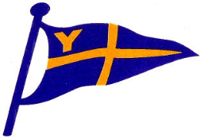
Yealm Yacht Club

The 28th ‘Summertime’ Trébeurden Race
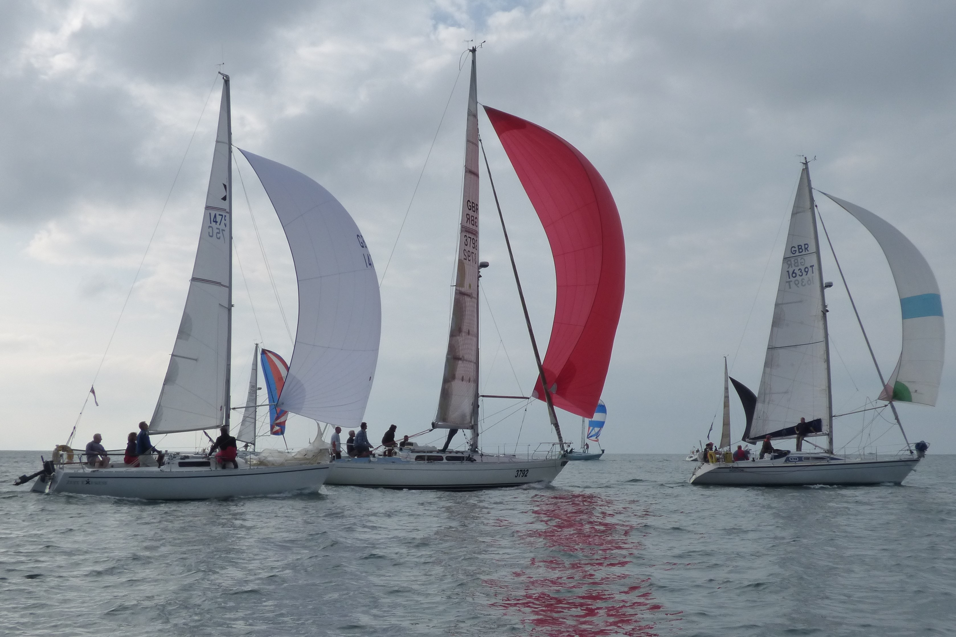
Thursday 21st June 2018, Start 1830 in Wembury Bay
Open to Class 1 IRC, Class 2 PHC & Class 3 MOCRA Multihulls
Entry Forms from the YYC Website yealmyachtclub.co.uk
Pre event BBQ and entertainment at YYC on Wednesday 20th June
One free night in Trebeurden Marina
Reception on night of arrival (modest charge for drinks)
Prize giving and Buffet Lunch Sat 23rd June (complimentary)
Follow on Race to Roscoff on Sun 24th June

