Yealm Yacht Club and UK Ballad Association 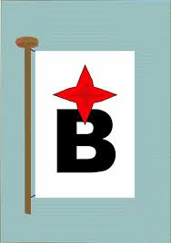

National Championships Entry Form 25th-28th May 2018

Name of Boat…………………………………… Sail No…………. White sail only? Yes/No

Name of owner………………………………… Home Club……………………………………

Address……………………………………………………………………………………………………………..
Email………………………………………………. Home phone ………………………………………..
Mobile Phone……………………………………. Work Phone ………………………………………..

Name of skipper ………………………………………….

Entry fees How Many Sum due

Championship fee (Including 3 nights mooring) £90-00
Friday eve simple supper** £9-00

Sat lunch pasty delivered to boat in estuary** £3-00

Sat Evening BBQ £9-00

Sunday Evening Prize Giving Dinner** £18-00

Mother Ship mooring (Max 35ft) £40-00

Total Payable

All social events at YYC. On Sunday evening the club will be open exclusively for Balladiers. Payment for this event must be in advance. Other social events at the club will be held whilst the club is open as normal. It may be busy, so to ensure your meal you are advised to pay in advance.

Payment
Bank Transfer Code 09-01-53 a/c number 08765486. Reference “ Ballad /boatname “.
Cheque Payable to Yealm Yacht Club boat name written on the back.

Entry Forms and cheques to Jon Pegg 8 Munro Avenue, Collaton Park, Newton Ferrers, Devon PL8 2NQ Email: thepeggs1973@gmail.com

Entries to be received by Friday 11th May.
Late entries may be accepted at the discretion of the organisers for an additional charge of £20-00

** Vegetarian Option available on request

