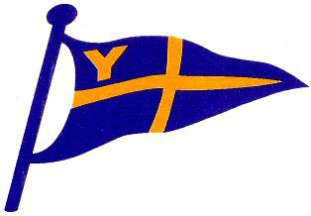 NOTICE OF RACE

RNLI YACHT AND DINGHY PASSAGE RACE
PLYMOUTH SOUND TO THE RIVER YEALM
ORGANISED BY THE YEALM YACHT CLUB

SATURDAY 9th June 2018

START IN PLYMOUTH SOUND (JENNYCLIFF BAY)
Start times from 12.30 BST
FINISH AT MOUTHSTONE POINT OR AT THE YEALM YACHT CLUB
(DEPENDENT UPON CLASS)

Followed by food and Refreshment at the Yealm Yacht Club from 13.30 onwards

The race will be governed by the current Racing Rules of Sailing and as amended, the Royal Yachting Association (RYA) prescriptions and Class Rules except as modified by the published sailing instructions.

The race is open to yachts with a Port of Plymouth Sailing Association TCF, and to dinghies, dayboats, keelboats, sportsboats and multihulls.

All helms must be aged 14 or over on the day of the race.

Courses;

Dinghies and Dayboats (including Cornish Shrimpers) from the start line, Western End of Plymouth Breakwater to Port, Mewstone to Port, both Yealm Sandbar navigation buoys to port and thence to the finish line at the Yealm Yacht Club.

Yachts, Keelboats, Sportsboats and multihull yachts ; from the start line, Western End of Plymouth Breakwater to Port, Draystone Buoy to Port, Mewstone to Port and thence to the Yealm Yacht Club finishing line at Mouthstone Point.

Entry form and full sailing instructions will be available at The Yealm Yacht Club at the address below, by email from cjtullett@btinternet.com, or under racing on website www.yealmyachtclub.co.uk

Completed entry forms with the entry fee are to be sent to PASSAGE RACE ENTRIES, Yealm Yacht Club, Riverside East, Newton Ferrers, Plymouth, PL8 1AE to be received by 2000hrs BST on Friday 8th June 2018

This is a charity race open to all comers, including those who may not race regularly. If you are uncertain which class to enter or how to get a handicap please contact
Chris Tullett 07508 483905 or email passagerace@yealmyachtclub.co.uk

Entry fees by 8th June - £8.00 to £16.00
(Dependent upon class)

