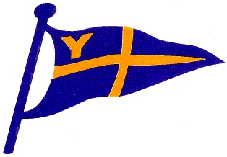
Yealm Yacht Club

Risk Assessment Form – Club Safety Boat Operation

Hazard | Risk | Control Measure
Environment – Dry land | - Slipping on stones  - Falling off walls  - Being hit by boats that are being launched or retrieved;  - Possibly while carrying boat equipment | - Warning notice at top of steps  - Wear suitable clothing and footwear for the activity  - Always report hazards that are evident  - Promote a culture of moving about deliberately/ thoughtfully  ** Please note  - First Aid kit in hut and boats  - VHF communications  - Potentially call emergency services (see “YYC Dinghy & Dayboat Crisis Management Plan”)  - RYA First Aid course recommended
Environment - Water | - Falling overboard  - Cold water shock  - Hypothermia  - Drowning | - It is a requirement that Safety Boat crews wear Lifejackets or Buoyancy Aids at all times  - Two handed manning of Safety Boats, a requirement of the Club Insurers  - Boats’ equipment to include a boarding ladder and survival bags  ** see note above.
Safety Boats’ equipment and sailing craft rig | - Being struck, squashed or dragged by gear (eg swiped by a boom of a boat that is being assisted, fingers trapped by gunwale) | - Encourage a culture of predicting when tricky situations may arise and act in an appropriate way  ** see note above.
Fire onboard Safety Boat | - Fire burns | - No smoking onboard the Safety Boat;  - No refuelling to take place while engine is running  - Fire extinguisher carried  ** see note above
Hierarchy of Risk
- Eliminate the risk if possible
- Reduce the risk to the absolute minimum
- Isolate the area from all but the operatives
- Control at all times
- Ensure that the correct PPE is used
- Ensure that risk assessments are adhered to

(First Assessed - April 2018)
Reviewed by Ian Kennedy, Rear Commodore (Sail) YYC - January 2020
Reviewed by Ian Kennedy, Rear Commodore (Sail) YYC - January 2021

