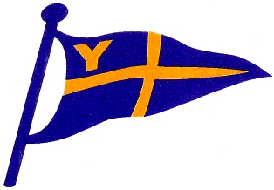

Yealm Yacht Club
Riverside Road East, Newton Ferrers, PLYMOUTH PL8 1AE

Yealm Yacht Club
Trebeurden Race Declaration Form

Date of Race Start: …….....23 June 2022...................................

Yacht Name: ………………………………… Sail No: ………………

Class …………….... IRC Number……………....PH Number……………………WS? N/Y

Start Time (BST) Hr…………......./Mins…........………../Secs……...............

Finishing Time (BST) Hr…………......./Mins…........………../Secs……...............

Yacht Ahead………………………………………………………..

Yacht Astern………………………………………………………

I declare that I was on board in charge of the above yacht during the race. All the Racing Rules of Sailing and the Sailing Instructions were obeyed and complied with throughout the race.

Name (CAPITALS)…………………………………………………………………

Signed…………………………………………………………………Date…………………

Please hand the completed form to the Race Officer, whats app, text or e-mail to the YYC Yacht Secretary asap after the race.

