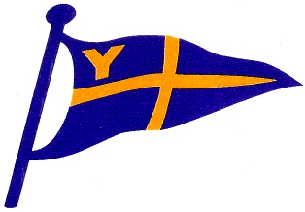
Yealm Yacht Club
Three Creeks Race
Race Instructions
Sat. 18th and Sun 19th May 2024
Contents
Event Schedule: 2
Timings: 2
Event Briefing 0830 Sat 18th May 2
Race Start: 3
Run 1 3
Transition 1 – Kingswear Marina 3
Sailing Leg 1 3
Transition 2 – East Portlemouth 3
Running Leg 2 3
Rowing Race start Sunday 0930AM and Sailing Leg 2 to Yealm 4
Transition 3 – Cellar Beach 4
Running Leg 3 4
Prize giving and BBQ 1700 onwards 4
1. General Rules 4
2 Sailing Rules 5
3 Running Rules 6
Running Kit List 6
Appendix A – Running Maps 7
Run 1 7
Run 2 8
Run 3 9

Event Schedule:
Time | Item | Location
Sat 18th May 0830 | Event briefing | Royal Dart Yacht Club, Kingswear
0930 | Race starts (run leg 1) | Kingswear
AM / PM | Teams sail to Salcombe
PM (end of Sat) | Complete Run 2 | Moor yachts in Salcombe Harbour as directed by Harbour Master
Sun 19th May 0930 | Rowing race to yachts | East Portlemouth Beach
Approx 10am | 2nd Sailing leg starts | Salcombe Harbour limits transit
PM | 3rd running leg | Finish at Yealm Yacht Club
1700 | Event cut-off time
1700 – onwards | Prize giving / bbq | Yealm Yacht Club

Timings:
The event is continuous, so you need to be slick at getting into your tender and getting to the beach. It is your total time that counts, including transitions, running and sailing.
The timings of the event are based on a fair bit of trust and team member participation!
Each team is required to capture the following information:
Race Start Sat: | 0930
Cross Start Line (Dartmouth)
Cross Finish Line (Salcombe)
Finish Run 2 (East Portlemouth Beach)
Race Start Sun | 0930
Cross Finish Line (Yealm)
Finish Run 3 (YYC)

Teams are encouraged to record their own running times as well, but this is not essential, it is only for interest and personal satisfaction. These times can then be posted as part of the results on the web site.

Event Briefing 0830 Sat 18th May
Held in Royal Dart Yacht Club, Priory St, Kingswear, Dartmouth TQ6 0AB. Tea, coffee, bacon or sausage roll breakfasts will be available for purchase.
Event briefing must be attended by all entrants. The runners starting leg 1 should come ready to run as there will not be time after the briefing to get back to yachts before the start.

Race Start:
Runners to gather as instructed at the briefing for an 0930 start.
Team members should have plenty of time to watch the start and return to yachts.

Run 1
Kingswear – Daymark – Inner Froward Point (the very bottom bit!) – Kingswear Marina
See Running Map 1 in Appendix A

Transition 1 – Kingswear Marina
Runners to enter Kingswear Marina and find their yacht, either in its berth from Friday night, or on the visitors pontoon to the south of the main marina. If the visitors pontoon is full, yachts must hold off safely in the estuary and come alongside for collection only. Runners MUST walk in the marina (at risk of disqualification) and sailing crews to manoeuvre carefully and safely once runners are aboard. A speed limit of 6 knots must be observed at all times, whilst proceeding to the start line.

Sailing Leg 1
The start line is the RDYC transit, located on Blackstone Point. Yacht engines must be switched off once the start line is crossed and the time of crossing the line recorded. Yachts must leave Western Blackstone Rock AND Homestone buoy to starboard.
Yachts are free to choose their best passage around Start Point to Salcombe Harbour.
The finish line (and point where engines must be turned on) is the Salcombe Harbour Limits, marked by a row of yellow buoys, and nominally when Great Eelstone Rock is on a bearing of 243 degrees. Time of crossing the finish line must be recorded.

Transition 2 – East Portlemouth
Runners to be taken ashore by tender from the yachts. They can either row themselves or be rowed by a member of the team. Yachts are to anchor or pick up a mooring in the vicinity of East Portlemouth and await the return of their runners. The race ends for the day, once runners set foot back on East Portlemouth beach. Once the runners are safely aboard yacht, proceed into the harbour to collect a visitors mooring (location to be advised by the harbour master).

Running Leg 2
East Portlemouth (Ferry Landing) – Prawle Point – East Portlemouth
See Running Map 2 in Appendix A
END OF DAY 1

DAY 2

Rowing Race start Sunday 0930AM and Sailing Leg 2 to Yealm
The race will re-start at 0930 on East Portlemouth Beach (or as advised at the event briefing) with a rowing race in a rubber, inflatable yacht tender (Avon or similar) to their yachts. Yachts will then proceed safely under power to cross the Salcombe harbour limit line, at which point engines must be switched off, and the time recorded.
The finish line is a transit between the two white poles on the cliff at the mouth of the Yealm Estuary, adjacent to Mouthstone Point. Yachts may proceed under engine to Cellars beach after crossing the Mouthstone Line and the time when the line crossed recorded.
The race committee reserve the right to amend the sailing instructions aligned to the conditions.

Transition 3 – Cellar Beach
Runners to be dropped or row to Cellar Beach. The footpath up the cliff is on the far LEFT HAND side of the beach as you look from the river. Please note, the path has changed since the event was last held, due to rock fall. It now goes along the estuary before going up to the coastal path.
Yachts to proceed into the River Yealm to collect a visitor mooring (location to be advised by the Harbour Master), before re-grouping with their runners who will finish at the Yealm Yacht Club, located: Riverside Rd East, Newton Ferrers, Plymouth PL8 1AE.

Running Leg 3
Cellar Beach – Coastal Path Run – Yealm Yacht Club. FINISH
See running map 3 in Appendix A

Prize giving and BBQ 1700 onwards
BBQ and drinks available at Yealm Yacht Club from 1700. Let the merriment commence!!

Rules
The aim of the 3 Creeks Race is for this to be a team sailing and running event, with maximum participation by all members of the team in both aspects. However, provided you stick to these few rules, it's your race to run however you wish!

General Rules
  - Teams can be up to a maximum of 5 and a minimum of 4.
  - At least one competent sailor must be on your boat at all times during the race.
  - Teams must communicate with the race officer in accordance with the communication instructions (to be confirmed at the briefing).
  - Youth team members (14 – 18) are welcome subject to a completed parental consent form.

Sailing Rules
  - The Race Committee consists of the Yealm Yacht Club (YYC) Sailing Committee and The Race Officer.
  - The race will be governed by the rules as defined in the Racing Rules of Sailing 2021-2024(RRS) and these Event Instructions.
  - All boats shall ensure that a valid RYA SafeTRX (replacement for CG66) is registered online.
  - Entrants should familiarise themselves with all hazards (particularly rocks and obstructions) associated with the race area.
  - Entrants must maintain a lookout for vessels engaged in diving and their accompanying divers and give them a wide berth.
  - Yachts should conform with the requirements of the ISAF Offshore regulations for a category 4 event
  - At least one mobile phone must be on at all times on each yacht, so the race officer can contact the team in an emergency, as a back up to the yacht VHF.
  - Yachts shall abide by the harbour regulations in force on the River Dart, Salcombe Estuary and River Yealm.
  - In the absence of any wind, human power of any kind is permitted to propel the vessel (rowing for example)

Disclaimer
  - A boat is entirely responsible for her own safety, whether afloat or ashore, and nothing, whether in the Notice of Race or Sailing Instructions or anywhere else, reduces this responsibility.
  - It is for a boat to decide whether she is fit to sail in the conditions in which she will find herself. By going to sea, the boat confirms that she is fit for those conditions and her crew is competent to sail and compete in them.
  - Nothing done by the organisers can reduce the responsibility of the boat nor will it make the organisers responsible for any loss, damage, death or personal injury, however it may have occurred, as a result of the boat taking part in the race. The organisers encompass everyone helping to run the race and the event, and include the organising authority, the race committee, race officers, and other assistants.
  - Each skipper is responsible to ensure that the vessel is seaworthy so as to be able to face extremes of weather; and that the safety equipment is properly maintained, stowed and in date and that the crew knows how to use it.
  - Each participating boat is required to hold adequate insurance and in particular to hold insurance against third-party claims in the sum of at least £3,000,000.

Handicapping
  - All entrants shall race in one class, using RORC’s RYA YTC handicapping system and Mocra combined.

Notices to Competitors
  - Any notices will be posted through the Facebook page, but may also be posted in addition as follows: Noticeboard in the Club, Skippers and Crews email. Late Changes to sailing Instructions will be transmitted on VHF Channel 72
Protests
  - Protests shall be written on forms available from the YYC and delivered within two hours of finishing. Protests will be heard as soon as possible.
  - Protest notices will be posted within 60 minutes of receipt to inform competitors where and when there is a hearing to which they are parties or named as witnesses.
  - The Protest Committee will be appointed by the Race Committee.

Running Rules
  - Runners are required to navigate around the course unaided, but may wish to use phones with navigation apps to assist with this. The ability to use a map and compass is a requirement.
  - Evidence of having followed the running routes is required. The type of evidence will be confirmed at the briefing but it is likely to be a ‘selfie’ picture (locations of each checkpoint also to be confirmed at the event briefing).
  - Each run must be undertaken with at least two members.
  - Running pairs must stay together at all times.
  - Runners should wear appropriate clothing for the conditions.
  - Footwear should have a suitably grippy sole, as the public footpaths tend to be muddy and slippy.
  - Runners must get to the shore in yacht tenders, under their own steam, not under engine.
  - If running pairs choose to leave their tender ashore whilst they complete a running leg, they shall ensure it is stowed appropriately above the high tide mark.

Running Kit List
Obligatory items:
- Map
- Compass
- Race number
- Mobile phone

Appendix A – Running Maps

Run 1

Run 2

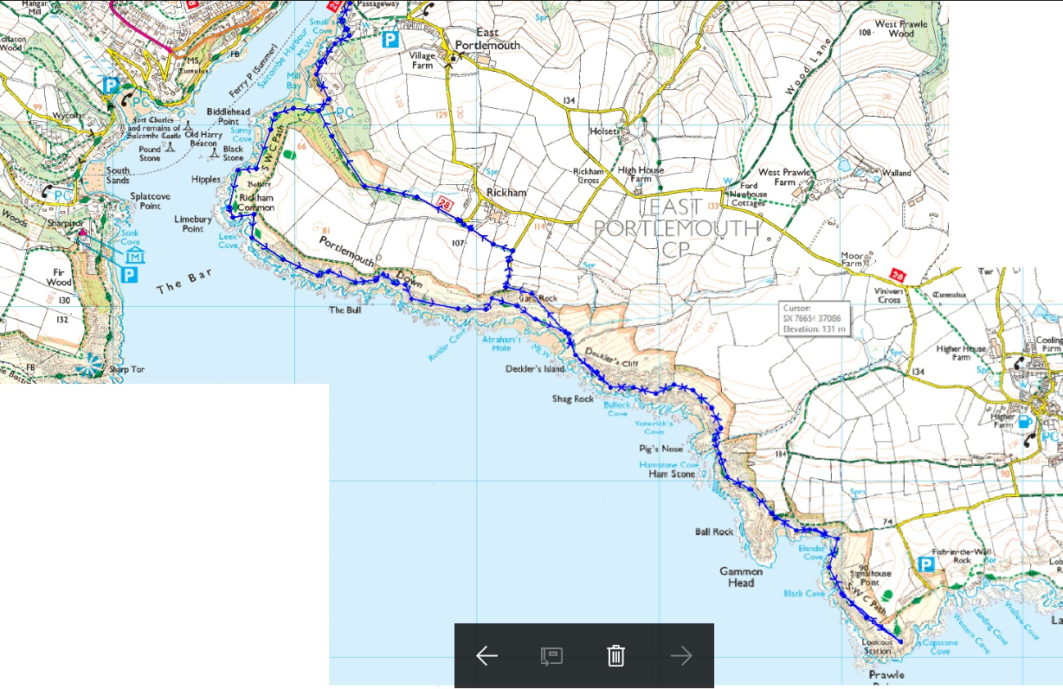

Run 3

FINISH AT YACHT CLUB
