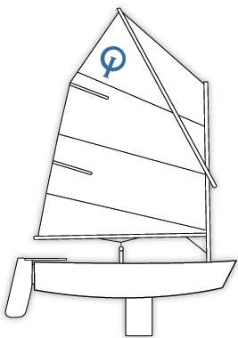
YYC OPTIMISTS
Enrolment & consent forms 2024

I would like to enrol my 8-12 year old child in a 3 session Optimist training course

Course 1 Beginners Tue 21st May 1600. Wed 22nd May 1630. Thurs 23rd May 1700

Course 2 Beginners. Tue 4th June 1600. Wed 5th June 1630. Thurs 6th June 1700

Which course
Name of Child (Children)
DOB
Name of Parent/Parents
Home address
Home phone number
Parent’s mobile / emergency contact
Parent’s email address

Fees Due
Beginners @ £20 per child
Taster family membership fee. £15-00
Total Due

METHOD OF PAYMENT & ENTRY
The preferred method is via BACS transfer to:
Account Name: Yealm Yacht Club

Account Number: 08765486

Account Sort Code: 09-01-53

Reference: Optimist sailing – parent surname

If paying by cheque, please make out to: “Yealm Yacht Club” and return the form to YYC in an envelope clearly marked “Optimist Sailing Fees”.

Declaration & Legal liability | Yes/No
I confirm that we hold Family Membership of Yealm Yacht Club
I confirm that I have applied for Family Taster Membership of YYC
I agree to pay all membership fees and course fees prior to sailing with YYC
I am aware that training will be led by properly qualified and experienced staff but will not be part of an RYA recognised training scheme.
I understand that the club shall not be liable for any loss, damage, death or personal injury
howsoever caused to any cadet as a result of their taking part in any YYC event.
I accept that I am responsible for my child, and that a responsible adult will be present during the sailing sessions.
I accept that nothing done by the organisers will relieve participants, or their parents, of their responsibilities.
I will inform the organisers in writing if I do not wish my child to be photographed at YYC events.
I am happy for you to hold my email address on the YYC database

I confirm that I have read and accept each of the above conditions.

Signed (Parent)……………………….....…………………………………..Date………………………………

Signed (Cadet)………………………….……………………….…………..Date………………………………

These forms can be electronically signed and returned to duncanmac2@gmail.com or printed and returned with payment to:
Yealm Yacht Club (Optimist sailing courses)
Riverside Road East
Newton Ferrers
PL8 1AE

with an email to say that forms and payment have been left at the club

